Flowchart : Pausedo-code

BEGIN

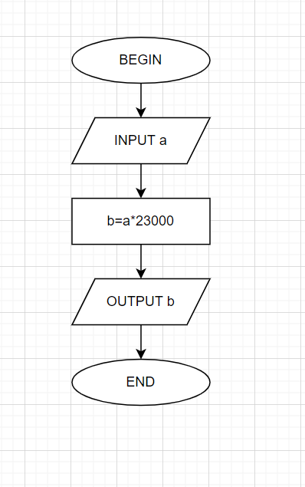 INPUT a;

b = a\*23000;

DISPLAY b;

END